Density of Restaurants in DAlLAS

# BUSINESS PROBLEM

Opening a restaurant is all about location, location, location. However, not every restaurant is suitable for every location, and vice versa. It comes down to a combination of restaurant concept and ideal customer. If we can define our restaurant type and identify our target demographic and its most populated areas, we can make a good decision on where to open the restaurant.

# INITIAL QUESTIONS

First, we need to identify where our ideal customers are located. We need to get answers to the following questions.

### **1. Describe Your Customers**

This is the most important question you can ask yourself when choosing the location of a restaurant. Who is your target market? In order to define this group of people, you’ll need to conduct specific research and come up with segmented customer profiles.

The first step is to describe your customers. You need to fully understand who your ideal customers are and what they all have in common. Like we mentioned in the section above, you’ll need to define their demographics, psychographics, as well as the associated behaviors, in order to get an accurate picture of who they are:

**Demographics** – Information such as age, gender, relationship status, median income, religion, environment, and ethnicity

**Psychographics** – Consumer personality type and personal preferences

**Behavior** – Similar behavior, such as likes and dislikes, hobbies, and extracurricular activities

### **2. Understand Their Habits**

### The second step is to **understand your customer’s decision-making process and buying habits.** Your target market’s demographics, psychographics, and overall behavior will dictate the way in which they make purchasing decisions.

Questions to ask yourself include, but aren’t limited to:

* Are they impulsive diners?
* Do they plan ahead when choosing a restaurant?
* Do they leverage Google, Yelp, OpenTable, and other information sources?
* Are they reliant on the recommendation of friends and family?
* What do they value most? Atmosphere? Service? Price?

### **3. Where Are They Located?**

Once you’ve identified your target market and drawn up the necessary customer profiles, you’ll need to figure out where your ideal customers are located. Remember that you want to put your restaurant in or around communities of your target market.

### **4. Are There Enough of Them?**

So, you’ve officially identified your target market and come up with specific customer profiles. You’ve then searched the Census data for the zip codes of communities that fit within your search radius and have the highest amount of your ideal customers.

### **5. Customer Activity: Foot & Vehicle Traffic**

But wait, there’s still something else you need when deciding if there’s enough of your consumers in an area to open a restaurant. It’s all about activity. You want to ensure that there’s enough traffic in each one of the locations on your list.

### **6. Competitor Analysis**

Another way you can identify where you’ll find your ideal customer type is to look at competing businesses. Restaurants often choose to be located next to their fiercest competitors. You’ll often see a McDonalds and a Burger King in the same vicinity, or a cluster of fine dining experiences in a downtown area.

This is because an established restaurant cluster of similar establishments is likely to have great restaurant location demographics. If you are confident about the quality of your restaurant experience, setting up near the competition establishes choice and gets local people thinking about dining out when they are in your area.

# DATA REQUIRED FOR

### **Competitor** analysis.

If there are already three pizza restaurants on a street, you’ll want to think long and hard before opening a fourth. There are no hard and fast rules on what constitutes market saturation. However, a good rule of thumb is whether or not you believe that your restaurant could thrive without taking away a big chunk of business from another good restaurant.

We are going to use Foursquare location data to find where are most fast food restaurants are located.

### **Complimentary** restaurants

Complimentary restaurants have concepts that are different from your restaurant, but their price points are often in the same range as your own. These complimentary restaurants help establish specific areas within a community that offer multiple eating options. Customers often seek out these areas to window shop and find what they’re craving in the moment. Sometimes your customers will eat with the complimentary restaurants, and other times they’ll eat with you. The benefit, however, is that complementary restaurants are less competitive than restaurants with the same concept as yours.

We are going to use Foursquare location data to find where are most fast food restaurants are located.

# DATA SOURCE

1. Getting the neighborhoods and the geo coordinates from [www.geonames.org](http://www.geonames.org)

URL: <http://www.geonames.org/search.html?q=Dallas&country=US>

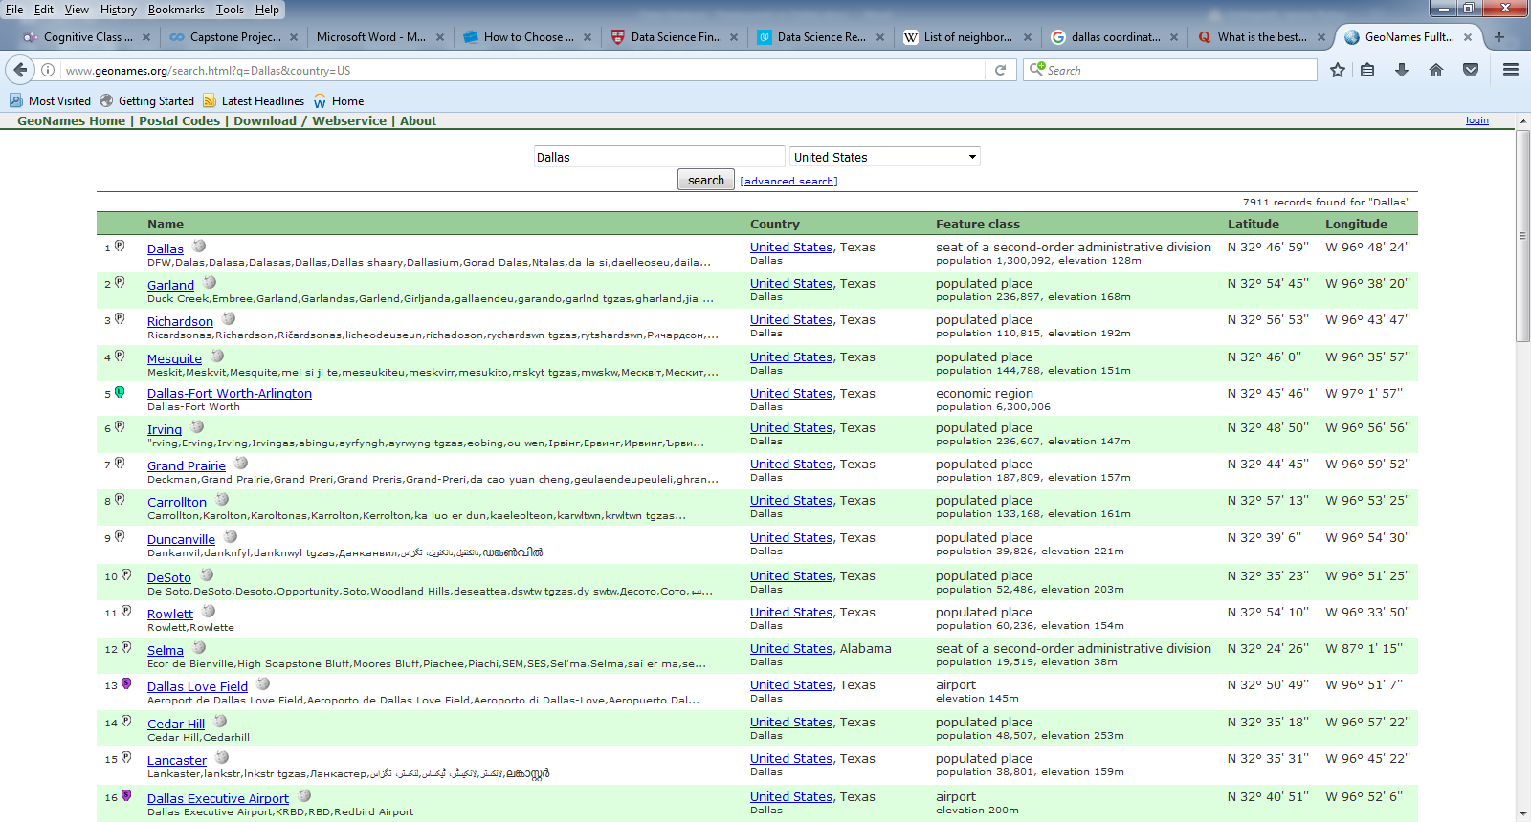

1. Foursquare for getting the restaurants located in the above locations

# DATA CLEANUP

On taking a closer look at the data imported from the web page we can see that there are various formatting issues which make the data unusable as is

1. Place the data in the appropriate columns

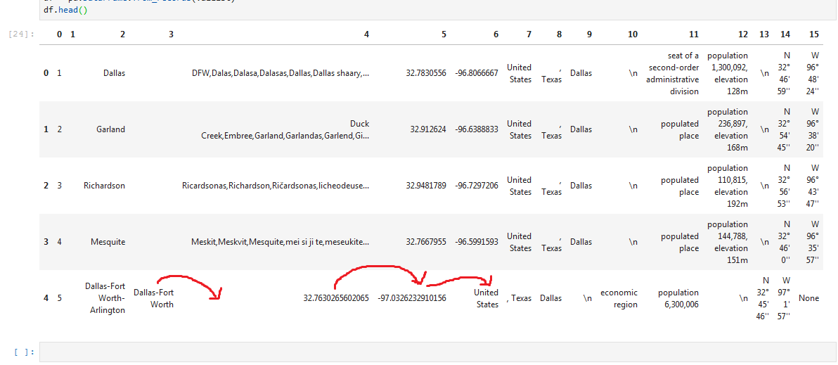

We can see in the above picture that in some rows (as the one highlighted above) the data needs to be moved to the next column.

1. Remove unnecessary data.

* There are some empty columns that need to be removed.
* Unnecessary columns such as Country and State need to be removed as we don’t need them

# RESULTS

We get the population of each neighborhood from the webpage and we get the number of restaurants in each of those neighborhoods using the **Foursquare API.** We calculate the density as the population of the neighborhood divided by the number of restaurants in the neighborhood.

Displaying only the first 5 records in the data frame

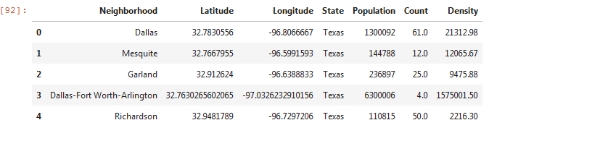

# VISUALIZATION

Displaying the data in the form of a bar chart. From the chart it is clear that Dallas FortWorth- Arlington has the highest density of restaurants.

